Andre Hardy – Project 11-1

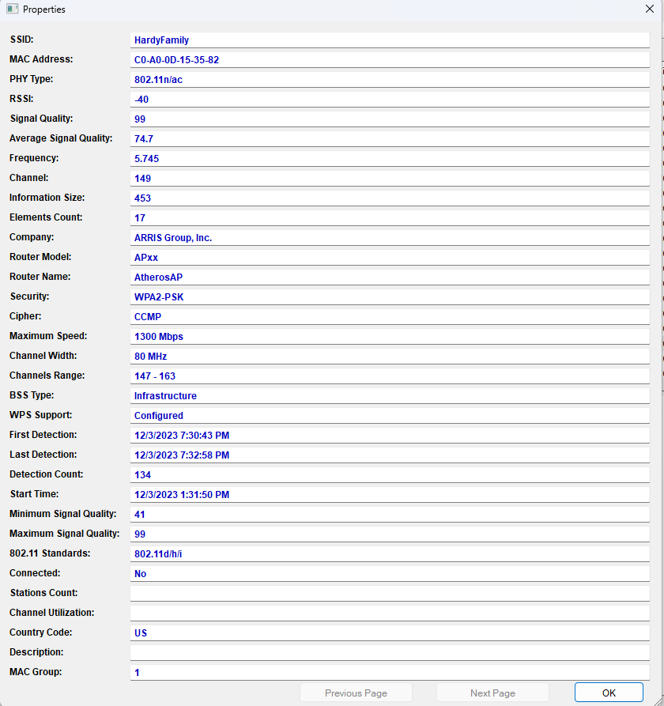

1. Use your web browser to go to www.nirsoft.net/utils/wifi_information_view.html. (If you are no longer able to access the site through the web address, use a search engine to search for “NirSoft WifiInfoView.”)
2. Scroll down and click download wifiInfoView. 3. Download the tool and when finished, extract the files and then launch the program. 4. Wait until WiFiInfoView displays all Wi-Fi networks that it detects. 5. Scan through the information that is displayed. Does the amount of available information from Wi-Fi networks to which you are not connected surprise you?
6. Scroll back to the first column of information. 7. Under SSId, is there a service set identifier for each network? Why would an SSID not appear? Does disabling the broadcast of the SSID name give any enhanced level of security? Why not?
8. Note the value under the column MAC Address. How could a threat actor use this information? 9. Under rSSI, the signal strength is displayed. (Lower numbers indicate a stronger signal.)
10. The Frequency column displays the frequency on which the network is transmitting, and the Channel column gives the corresponding channel. Click Channel to sort the channels. Is there any channel overlap? How could this be a problem?
11. Double-click the Wi-Fi network to which you are currently connected. A window is displayed showing the available information that is being transmitted through the Wi-Fi. This is information regarding your Wi-Fi network that anyone can see. Close this window.
Copyright 2022 Cengage Learning. All Rights Reserved. May not be copied, scanned, or duplicated, in whole or in part. Due to electronic rights, some third party content may be suppressed from the eBook and/or eChapter(s). Editorial review has deemed that any suppressed content does not materially affect the overall learning experience. Cengage Learning reserves the right to remove additional content at any time if subsequent rights restrictions require it.
c. It is a subset of WPA2. d. It is a technology used by IEEE 802.11 for encryption.
19. Minh has been asked to recommend an EAP for a system that uses both passwords and tokens with TLS. Which should she recommend? a. EAP-FAST b. EAP-TLS c. EAP-TTLS d. EAP-SSL
20. Which of these is NOT a type of wireless AP probe? a. Wireless device probe b. WNIC probe c. Dedicated probe d. AP probe Module 11 Wireless NeTWork securiTy
12. Now select a network other than the one to which you are connected and double-click it to display information. After reading the information, close the window.
13. Scroll to the Security and Cipher columns. What security are the networks using? 14. Scroll to wPS Support. How many networks have WPS turned on? Is this secure? 15. What additional information do you find useful? What information would a threat actor find useful? 16. Close all windows.

